Scientific American 6 mei 2016

Catastrophic Canadian Wildfire Is a Sign of Destruction to Come
Less snow and warmer spring mean more acres burned Mark Fischetti on May 6, 2016
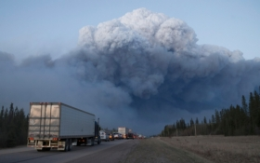
FORT MCMURRAY, AB - MAY 05, 2016: Drivers wait for clearance to take firefighting supplies into town on May 05, 2016 outside of Fort McMurray, Alberta. Wildfires, which are still burning out of control, have forced the evacuation of more than 80,000 residents from the town. Credit: Scott Olson/Getty Images
The intense wildfire that has forced thousands of people to evacuate Fort McMurray and surrounding areas in Alberta arrived early in the wildfire season, fueled by hot, windy weather. Scientists say big fires will ignite sooner and sooner in the year in the western U.S. and Canada as the snow pack continues to dwindle during warmer winters or dries out sooner during warmer springs, leaving terrain parched for more weeks of the year. In the American West a 1-degree Celsius rise in average temperature could increase the annual acreage burned by up to 600 percent in certain regions. See the map below for details.

Sources: University of Washington; U.S. Forest Service
Graphic by Bryan Christie
This map was first posted online May 17, 2011. --------------------→

