
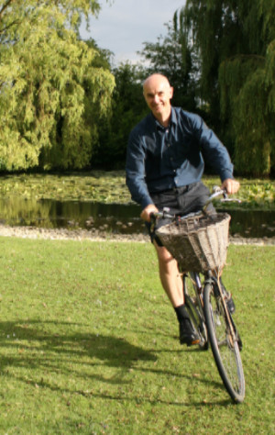

David JC MacKay: a publisher's memories of a remarkable man and his remarkable book
In 2008 UIT Cambridge published David MacKay's book, Sustainable Energy - without the hot air. I have worked with him as editor and publisher and known him as a friend in the eight years since then. These recollections are from my personal experience, so they focus on his book and related events. Several other tributes to him cover his wider life and work, especially in The Guardian and The Telegraph.
Niall Mansfield, Publisher, UIT Cambridge Ltd.

Sustainable Energy - without the hot air - a book that deals with divisive issues such as wind farms and nuclear power - is endorsed by a very unlikely mixture of people, from EDF (one of the world's major nuclear power generators) and the Shell oil company, to members of Friends of the Earth and Greenpeace. Why did it have such a profound influence across the world, getting rave reviews from such diametrically opposed groups? The are several reasons: David's reasons for writing the book, how it was written, how it was published, and how it was promoted. In each aspect, David's sense of purpose dominated.

How the book came about, and why
The genesis of the book was a campfire discussion in Africa in the mid-2000s, about sustainable sources of energy. Most people present said that wind and wave power are so abundant that there's no need for fossil fuels. Only one person (from South Africa?) dissented, saying that wind and wave were plentiful, but on nowhere near the scale needed to power the world. That was the end of productive discussion; without real data about energy use and calculations of possible energy sources, any debate was bound to be hot air, producing more heat than light. So David decided to produce the data and do the calculations -- to cut out "the twaddle" and produce "a straight-talking book about the numbers". (His interest in the environment was longstanding. When he was at Caltech for his PhD around 1990, he instigated a recycling scheme, and Caltech now has sophisticated recycling across the campus.)
Over the next three or four years, David produced several drafts of his book, and published them on the web for people to comment on. This had three important effects:
- He got feedback from people interested in the subject, on which topics to cover, and information about those topics. (The Acknowledgements in the book list about 350 people who helped one way or another.)
- Readers commented on how readable and how understandable the written material was.
- A growing number of people became aware of David's work, (which was to prove important when the book was finally published).
Later on when I got to know David, I realized that doing things this way stemmed from his particular character. He wanted to get things correct. He was neither falsely modest nor conceited, so he accepted suggestions and corrections without any intrusion of ego. If someone else was right, their contribution was very welcome, because it improved the book.
Similarly, reader comments made it clear that how clearly the material was expressed was crucial to people's understanding. This is why he eventually expressed all energy use in kilowatt hours, per person per day (kWh/p/d). Superficially this a minor issue, but in fact it's very important because his book is essentially quantitative. However, national energy use is so huge that ordinary people can't relate to it. ("The electricity generating capacity of the UK is 92 gigawatts."). David's insight was to choose units where the numbers involved were (a) familiar - kWh are the units on our electricity and gas bills (b) small enough to be understandable, i.e. mostly units and tens, which the "per day" gives us, and (c) easily related to an individual's own activities, which is why "per person" is so important. For example, in the UK, a person's average energy consumption in a day is 125 kWh. "Taking a bath uses about 5kWh ... a shower uses 1.4kWh". Expressing consumption in simple numbers likes these gives you a true understanding of your own behaviour. Driving a car 30 miles a day uses about 40kWh/day -- about a third of the 125 kWh average -- so reducing your driving can make a big difference to your overall energy consumption. At the time of publication, there had been a big campaign for people to save energy by switching off their phone charger. The book pointed out that switching off your charger for a year would save the same amount of energy as one hot bath. Choosing the right units gave people a handle on the numbers and showed how campaigns like these were like “bailing the Titanic with a teaspoon”.
There are other features that make the book special. The first is David's understated humour. The book is about serious issues, but it's neither po-faced nor gloomy: it's an optimistic and fun book to read. Second is the deep insight that David had into the physics of the world. While he had a wonderful facility with mathematics, his particular gift was back-of-the-envelope calculations that made the underlying physical principles clear, without obscuring them in mathematical complexities. As a result, his book is not just informative, but educative -- having read it, readers come away with a new set of skills for analyzing and understanding energy issues. Finally, much of the book's information is presented graphically, very clearly and simply without "chartjunk", following the precepts in Edward Tufte's "The Visual Display of Quantitative Information" (which is itself a seminal book, and incidentally was self-published in 1992, when self-publishing was almost unheard of).
By mid-2008 the book was in the form of a complete draft. On 23-June-2008, I received this message:
Dear Niall,
Leo Smith gave me your name because he thought you might be able to help me. I'm writing a popular book on "Sustainable Energy - without the hot air". http://www.withouthotair.com
I'm looking around for an agent to help me with publication, and for a trade publisher. If you have any ideas, I'd appreciate them. thanks very much, David MacKay
On 26-June we met for lunch in Darwin, David's college in Cambridge. David was insistent that a PDF of the book had to be available free on the web, and that he wasn't writing the book to make money -- it was to help people understand about sustainable energy. The book was to be published under a Creative Commons licence that would allow others to build on his work. (Given his untimely death, a prescient decision.) As publishers, we trembled at the idea of printing thousands of books but selling none,because everybody would just download the free PDF. So David said he would buy 1000 books upfront at half price, to mitigate our risk. I did point out that at that stage we had published primarily professional and academic books, but by the end of lunch we agreed to go ahead. We started work on the book at 4:30 that afternoon. (Later I learned that a number of other publishers had declined the book, because of the “free PDF” issue.)
David was hugely demanding, which led to a few tense meetings, but after a while things were fine, because I realized a couple of things about David. First, because of his no false modestly and his brain the size of a planet, when he said he was right, he was. Second, when we as editors could improve the book, he incorporated our suggestions more than willingly; there was no ego involved - what mattered was making the book better. Working with David was very productive and it was especially pleasing that such a cooperative mode of working (on the book itself and plans for promoting it) led to such success later. That time was the beginning of a friendship which lasted until David's death.
As we progressed with the editing, one big decision decision was that the book would not present conclusions: it would present the facts and figures, but assume that the readers were intelligent, and they should make up their own minds. With hindsight, this was crucial. Any pronouncement ("wind farms will save the world", or "wind farms are the work of the devil") would at a stroke reduce the book's audience by 50%. And it would have been against the whole purpose of the book, which was not to impose some favourite option of David's on people, but to give people the real numbers, so that the could concentrate on the other factors involved. I think that explains why both environmental activists and nuclear power companies could endorse the book. More broadly, it explains why the book has been so influential: in essence, it says "Here are the numbers. They're all founded on basic physics so they're correct and you can stop arguing about them." In this way the book removed the physics dimension from the discussion and forced people to address the grey and much more difficult facets of energy policy: public acceptability, politics, and economic factors. There's still endless scope for disagreement, but now the arguments centre on the real issues. (Later on, UIT applied the same criteria to create a series of "Without the hot air [TM]" books, covering subjects such as Drugs, Urban Transport, and Sustainable Materials.)

The book goes to press
Editing the book took about four months, and in mid-November 2008 we went to press. A week or two earlier, we and David agreed to launch the book at the Cambridge Society for the Application of Research, where David was scheduled to speak on 1-December. (Working to this sort of ridiculously short deadlines with no lead time for publicity etc. gives publishing people apoplexy.) Anyway, David told me to bring along a lot of copies of the book, because the event would be very well attended. Now, every publisher knows that every author believes that their book is wonderful, and will appeal to everybody in the world. (This is perfectly natural: an author has spent one or two years alone in an attic, expending blood sweat and tears. So as publishers we internally -- and silently -- made our own assessments of how the event would go, but taking along a few extra cartons of books wasn't a big deal, so we did.) In the event, the auditorium was literally overflowing -- there were people standing on tip-toe outside the doors, peeping in over the crowds in the aisles. And in the foyer afterwards we sold 5-10 times more books than at any other book event; so much for our "wisdom". Again, David's being neither conceited nor falsely modest required us to make mental adjustments. He knew from his earlier web discussions that there was pent-up demand for the book.
At the beginning, the book sold well. David had a simple policy of giving a copy of the book to as many influential people as possible: politicians, scientists, engineers, energy industry people, authors, journalists, energy regulators, etc. (I think his motivation made this easier than it might have been. It wasn't a case of "I'm very clever and here is my clever book", rather it was "Sustainable energy is important and this book will help you understand the issues.") David also spoke publicly as often as possible, from events in small village halls in rural Cambridgeshire and local bookshops, to major events in London. In parallel, at UIT we did a huge amount of publicity work, again ranging from small local events and publications, to large publications with worldwide reach. (Our view was "It doesn't matter how small, it won't do any harm and it might do some good.") We had good relations with Heffers, the main academic bookseller in Cambridge, where Desirae Vanek championed the book to all the other bookstores in the Blackwells group. By the end of 2009, David's book was Heffers' best-selling book across the whole store, so they had a special "Book of the Year" display for it in Jan-2010. (Another less welcome tribute was the pirating of the book. Someone printed hardcopies of an obsolete draft of the book - including the page footer showing it was out of date! - and sold them on Amazon.)

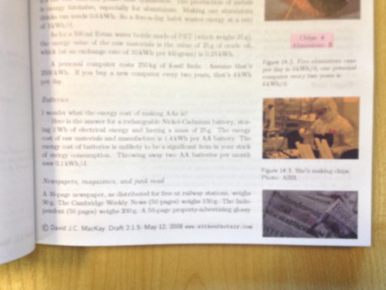

April-2009 was crucial: almost simultaneously, we got major and very favourable reviews in the Guardian, the Financial Times, the Economist, and on the Boing Boing blog. Sales surged dramatically, so we printed another 15,000 copies. (As of April-2016, there are 75,000 copies in print in English. Around 2010, because the book had done so well we "repaid" David's initial purchase of 1000 copies with another free 1000 copies.)
In spite of the book's popularity, it was clear with had a problem with the original cover:

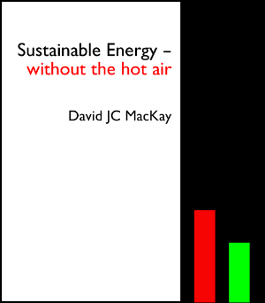

Boing Boing noted the "austere cover and spartan title", and the Guardian was even more direct: "It has a crashingly dull cover and title". So we engaged a great trade-book cover designer, Jon Gray, to give the book an image more suitable to the general trade audience the book was starting to reach. Booksellers and readers liked the result:

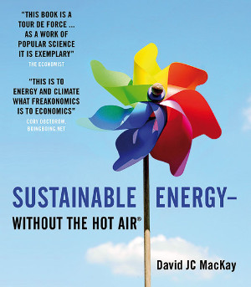

although a few commented that while the old cover was less attractive, it did graphically encapsulate the idea of the book.

David's influence starts to spread
Also in early 2009, the top civil servant in the UK's Department of Energy and Climate Change (DECC) bought a copy of the book in Heffers in Cambridge, showed it to her staff, and said they had to talk to this author. As a result, David was appointed Chief Scientific Advisor to DECC, in September 2009. David had asked the advice of his friends about taking up the appointment: a frequent suggestion was that he might find the bureaucracy frustrating. In a talk ("My first 100 days in government") he gave a few months later, he recounted this, and was very happy to say that on the contrary he found his work colleagues very able and very dedicated.
Clearly the book was having significant influence in the UK, but David's appointment to DECC raised that to another level. He was able to apply his abilities directly to government and influence national energy policy. To make the issues more accessible, he and DECC staff created the "2050 calculator". In effect, this is a huge interactive webpage: you change sliders (say to have zero nuclear power, but the maximum possible land-based wind power) and immediately see graphically the effect on CO2 emissions. Everybody -- the public, the civil service, and industry -- could now easily experiment with many different ways of meeting the UK’s target to reduce CO2 emissions by 80% before 2050. To encourage debate and understanding, DECC invited other parties to contribute their own "pathways" or views of the future, as sets of 2050 calculator settings; contributors included Friends of the Earth, the Campaign to Protect Rural England, National Grid, and energy consultants.
David's influence was starting to extend beyond the UK. In the first instance his book was having worldwide reach. People who had been inspired by David's message started translating the book, and because it was published under Creative Commons, they were able to distribute copies free. In parallel, Japanese, French, Hungarian and Chinese publishers brought out commercial hardcopy translations of the book. We also heard that copies of the book were brought to the White House and given to Energy Secretary Steven Chu; the person who brought the book was one of the US's top entrepreneurs, so it's likely Secretary Chu did read the book.
David's influence was worldwide in another way. The 2050 calculator was published as free, open, software. With DECC's encouragement, other countries including China, Taiwan, Japan, soon continued the work, developing versions for their countries. About 20 countries in all have produced or are working on their own calculators. DECC then went on to produce the World Calculator, to show the total world CO2 emissions picture, not just details for specific countries.
Working with David had shown us the importance of providing good information about sustainability. In 2013, we heard that another publisher, Green Books, would need a purchaser because senior staff were retiring. Green books had a long history in books on sustainability and especially on the Transition movement which focussed on issues of peak oil. UIT purchased Green Books, and again David showed his generosity and support by lending us money (with nothing more than an emailed IOU as documentation).
Also in 2013 David was appointed to the newly created Regius Professorship of Engineering back in Cambridge, and in 2014 he finally moved from DECC. In 2016, he was awarded a knighthood ("Sir David MacKay") for services to scientific advice in government and science outreach. When we were preparing the latest reprint of the book in January-2016, we asked David whether he'd like us to change the photo in the book that shows him with a big smile zooming on his ever-present bike; maybe it didn't have the gravitas for a knight. But he thought it conveys the spirit of his book, so this is the photo that remains in the book.

Cancer diagnosed
Out of the blue in mid-July 2015, David had been diagnosed with stomach cancer. On 6-August-2015 he emailed me:
I'm on the number 2 treatment plan. - chemo starts next week. Continues for 24 weeks. I get to keep my stomach, which I'm happy about.
I thought the last bit was at least some consolation, but didn't realize that it was a typically understated David message. The only reason he would keep his stomach was that the cancer was so far advanced that surgery wasn't an option. His priority now was being with his wife and family, and having fun with them to create memories for his children (ages 4 and 1). He continued to work, but his illness and the effect of his medication severely limited what he could do. In September-2015, it was announced that he was the 2016 Breakthrough Paradigm Award winner.

Throughout all the time I knew him, David emphasized the numbers -- to look at the facts and the statistics. During his illness was no exception. He blogged, documenting his treatment and progress, continuing until very shortly before he died:
http://itila.blogspot.co.uk/2015/08/unexpected-signs-of-malignancy.html
The blog is a remarkably unsentimental analysis of his illness, and the likelihood of recovery, or survival for a given period. He presents a lot of the information graphically, again inspired by Tufte. Sadly, Tufte's very clear graphic showed only a 24% chance of surviving for five years. While one admires David's objectivity in his blog writing and his continued dedication to the truth of numbers, reading the blog is heart-rending.
On Monday 11-April-2016, on my way to London for a week of the London Book Fair, I received an email from David:
I'm starting my seventh day in Addenbrookes [hospital]. I have perked up a little. … How about [meeting on] Friday night or Saturday or Sunday?
David died on the afternoon of Thursday 14-April.

In memory of David you can donate to the Arthur Rank Hospice Charity at
https://www.justgiving.com/fundraising/davidjcmackay
So far, the fund has raised more than five times its target.

