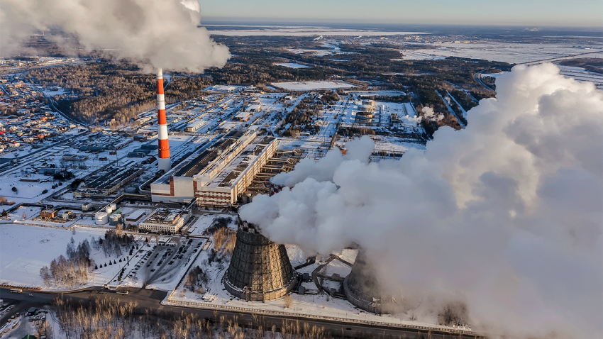
Power plants, like this one in Tyumen, Russia, let off air pollution that contains many nanoparticles, including magnetite. A new study finds this magnetite can make its way into human brains.
Sergei Butorin/iStockphoto

Industrial air pollution leaves magnetic waste in the brain
By Michael PriceSep. 5, 2016 , 3:00 PM
If you live in an urban environment, chances are you’ve got nanomagnets on the brain—literally. New research suggests that most magnetite found in the human brain, a magnetic iron oxide compound, comes from industrial air pollution. And because unusually high concentrations of magnetite are found in the brains of people with Alzheimer’s disease, the findings raise the specter of an alarming new environmental risk factor for this and other neurodegenerative diseases. Still, other scientists caution that the link remains speculative.
For decades, scientists have known the brain harbors magnetic particles, but most assumed that they derived naturally from the iron used in normal brain function. About 25 years ago, geophysicist Joe Kirschvink at California Institute of Technology in Pasadena detected biologically formed magnetite particles in human brains, lending evidence to their natural origin.
The problem with magnetite is that it’s toxic. It causes oxidative stress, disrupting normal cellular function and contributing to the creation of destructive free radicals—unstable molecules that can damage other important molecules. Previous work has also shown a correlation between high amounts of brain magnetite and Alzheimer’s disease, and recent studies suggest it increases the toxicity of the disease’s hallmark β amyloid plaques, clumps of protein that can interfere with cell signaling. Nothing definitively links magnetite to Alzheimer’s, but the kinds of cellular damage it can cause are consistent with what’s seen in the disease.
Physicist Barbara Maher, co-director of the Centre for Environmental Magnetism and Paleomagnetism at Lancaster University in the United Kingdom, wondered whether all the magnetite found in the brain could be traced to biological processes. As an expert in environmental magnetic particles, she knew that many, including magnetite, are prevalent in air pollution let off by power plant smokestacks.
“The paradigm until now has been that magnetite just forms naturally in the brain,” Maher says. “Given how prolific magnetite particles are in the atmosphere, I wondered if they had gained entry into the human brain.”
So Maher and a team of U.K. and Mexican scientists looked at postmortem samples of brain matter from the frontal cortexes of 37 human brains. Most came from people who lived in Mexico City, and others came from former residents of Manchester, U.K. Using a variety of high-resolution imaging techniques, the researchers examined the characteristics of the brain samples’ magnetite.
Biological magnetite usually forms in tetrahedral or octahedral shapes, but the vast majority of magnetite particles found in this study were instead round nanospheres (like the one below). The researchers detected other unexpected metallic nanoparticles in the brain samples, too: platinum, nickel, and cobalt. None of these metals occurs naturally in the brain, suggesting an environmental origin.
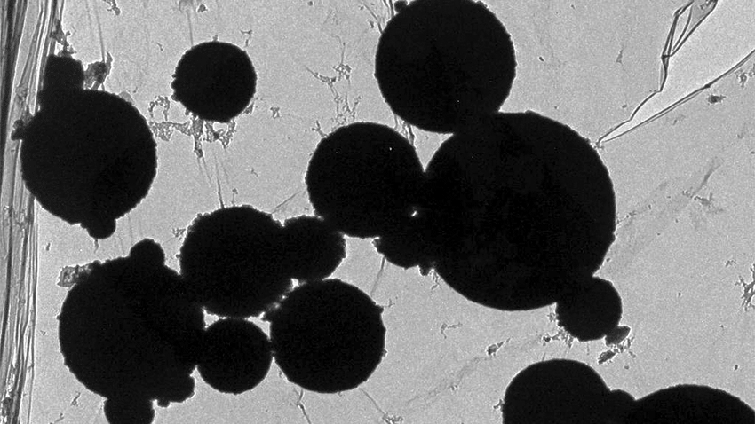
These magnetite nanospheres, found in pollution from the United Kingdom's Didcot power station, match the magnetite researchers found in human brain samples.
Barbara Maher
For Maher, the magnetite’s nanosphere shape, combined with the presence of the other metals, was a tell-tale sign. “They showed all the properties suggesting they formed in high temperatures,” she says. Those temperatures vary with the fuel being burned, but they are much higher than those of the human body. “[The nanospheres are] combustion byproducts, like what’s found in power station pollution.” Frictional heating, like what happens to a car’s brake pads, can also produce magnetite nanospheres, she adds.
The researchers found biologically formed magnetite, too, but for every one of those particles, they found at least 100 pollution-derived magnetite particles, they report today in the Proceedings of the National Academy of Sciences. That comes out to millions of magnetite particles per gram of brain matter, Maher says.
At 150 nanometers or less in diameter, these magnetite nanoparticles are small enough to be inhaled through the nose and enter the brain through the olfactory bulb, Maher explains. Previous air quality studies in the United Kingdom and Mexico City have found that urban areas, especially along roadsides, have abundant airborne magnetite, she adds, providing plenty of opportunity for people to sniff these toxic nanoparticles into their brain.
Other environmental risk factors for Alzheimer’s and other neurodegenerative diseases have been suggested, and it’s not clear how magnetite fits into the overall risk picture, or whether there’s an exposure threshold that’s especially dangerous. Still, the results deserve special attention from epidemiologists and air quality policymakers, Maher says. “It’s an unfortunately plausible risk factor, and it’s worth taking precautions. Policymakers have tried to account for this in their environmental regulations, but maybe those need to be revised.”
Kirschvink, the first scientist to detect biologically derived magnetite in the brain 25 years ago, is convinced that the researchers have indeed found evidence that magnetite can be introduced through air pollution. The especially high levels of magnetite found in the study’s brain samples are shocking, he says, though not necessarily surprising given that they lived and worked in industrial environments with lots of air pollution.
Still, he’s concerned that researchers found so much environmental magnetite in the brain. Such magnetite is more dangerous than biogenic versions of the particle, he says. “Once you start getting larger volumes of [environmental] magnetite, the chemical reactivity goes way up,” he says. “That nanoparticles of industrially generated magnetite are able to make their way into the brain tissues is disturbing.”
Jennifer Pocock, a neurologist at University College London, says in a statement through the independent Science Media Centre that although she agrees the evidence points to pollution-borne magnetite in the brain, more work is needed before a solid connection to Alzheimer’s can be drawn. “There needs to be a better study carried out to correlate the magnetite concentrations of patients who lived primarily in a city, for example, compared with patients living in relatively unpolluted area, and analyses of their Alzheimer’s disease brain pathology correlated with magnetite concentrations."
*Update, 6 September, 7:07 a.m.: This story has been updated to add a reaction from Jennifer Pocock, a neurologist at University College London.
Posted in:
- Brain & Behavior
- Chemistry
- Environment
- Health
DOI: 10.1126/science.aah7262

Michael Price
Michael Price is a former scientific employment and training writer at Science Careers.

