Bloomberg

Warren Buffett Says Berkshire Is Reversing Course on Airlines—Again
By Katherine Chiglinsky May 3, 2020

- Berkshire exited stakes in Delta, United, American, Southwest
- ‘The world changed for airlines,’ Buffett said at his meeting
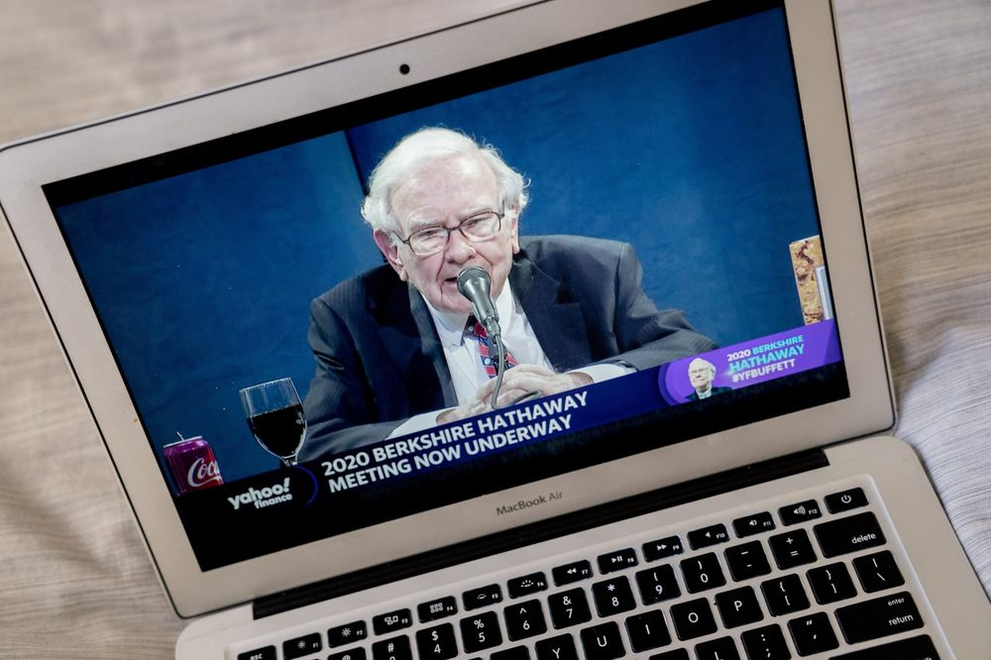
Warren Buffett speaks during the virtual Berkshire Hathaway annual shareholders meeting on May 2.
Photographer: Andrew Harrer/Bloomberg

In this article
Warren Buffett is reversing course on his airlines bet -- again.
The billionaire investor said Berkshire Hathaway Inc. completely exited its stakes in the four major U.S. airlines. The sales of shares of Delta Air Lines Inc., Southwest Airlines Co., American Airlines Group Inc. and United Airlines Holdings Inc. made up most of the company’s $6.5 billion in equity sales in April.
During his live-streamed annual meeting, Buffett said the business has fundamentally changed following the economic fallout from the coronavirus pandemic. He declined to blame the performance of the airline executives, saying they’ve done a good job of raising money to get through the crisis.
“The world changed for airlines and I wish them well,” Buffett said Saturday. He clarified that he made the decision and that he lost money on his investments. “That was my mistake.”
Buffett’s had a complicated relationship with the airline industry over the years. After a troublesome investment in USAir, Buffett joked that he would call an 800 number to declare he was an “air-o-holic” if he ever got the urge to invest in airlines again.
Then in 2016, Berkshire dove into the industry again, amassing stakes in the four largest U.S. airlines. At the end of 2019, those stakes amounted to almost $10 billion. Buffett’s renewed faith in the industry prompted speculation that he might one day own one of the carriers.
An $85 Billion Airline Rescue May Only Prolong the Pain
But now, he’s cut those investments again. Berkshire disclosed in April that it had at least trimmed its Delta and Southwest stakes, both of which had previously been above a 10% ownership level.
“The airline business -- and I may be wrong and I hope I’m wrong -- but I think it’s changed in a very major way,” Buffett said. “The future is much less clear to me.”
The disclosure was among the most significant at the annual meeting, which was notable for its different feel this year as the event that usually draws tens of thousands was hosted virtually. Buffett, 89, shared the stage with a top deputy, Greg Abel, who runs Berkshire’s non-insurance operating units. Vice Chairman Charlie Munger, 96, didn’t join, though Buffett said his longtime business partner was in good health.
Buffett said he didn’t know how consumer travel habits will change after the pandemic subsides, but any reduction in travel could leave airlines with higher-than-necessary fixed costs. Any impact could filter down to suppliers like Boeing Co.
“The real question is whether you need a lot of new planes or not,” he said.
Buffett said the efforts to slow the pandemic amounted to “quite an experiment,” and while the range of public health and economic outcomes has narrowed, they remain “enormous.”
“I don’t know the consequences” of shutting down large parts of the U.S. economy, Buffett said, though Berkshire’s operating earnings will be “considerably less” than if the virus hadn’t hit.
Buffett gave an extended history lesson to back up his assertion that “nothing basically can stop America.” He said he’s still bullish on the U.S. economy because it has overcome many obstacles over the past two centuries, though “we haven’t faced anything that quite resembles this.”

www.bloomberg.com/news/articles/2020-05-02/buffett-says-berkshire-reversing-course-on-airlines-again

